It’s very easy to create AI model with autoML ==> Win time.

3 types:

AutoML Vision (image data)

AutoML Natural Language (text-based data)

AutoML Tables (Tabular data)

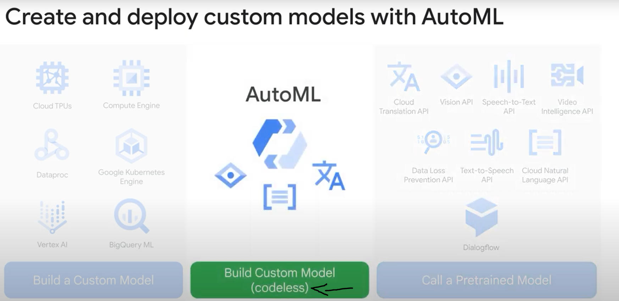

A model is trained, specific to your data (better than using pretrained models that use general data)

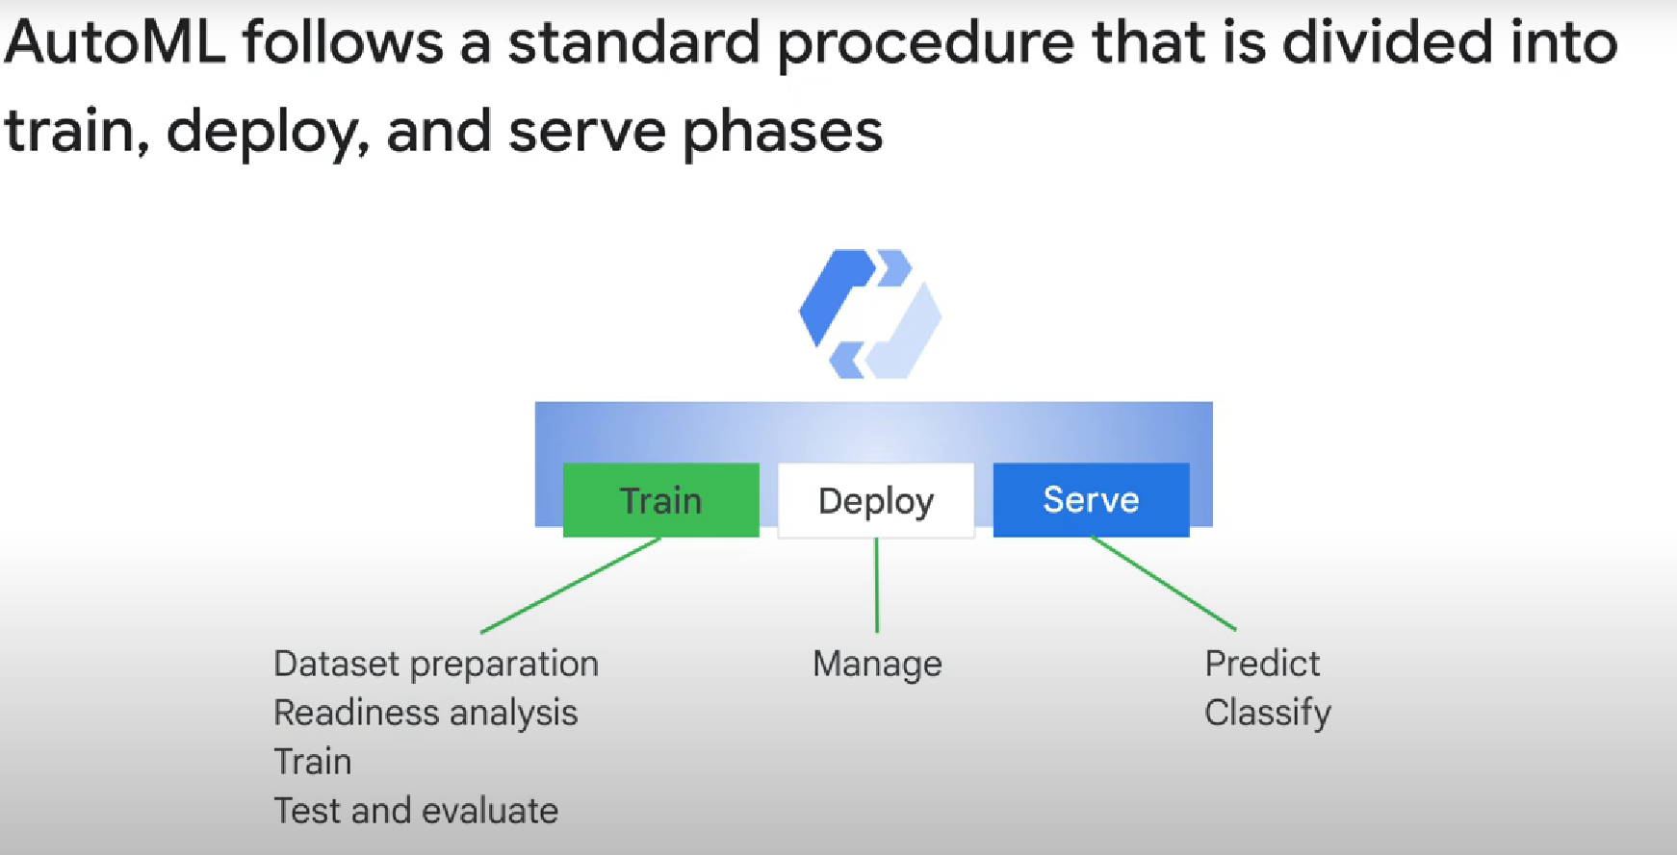

Dataset prep vs readiness analysis:

First, you have to prepare a data set that will be used in the supervised training process. Next, you need to analyze the data set to make sure it has qualities that will enable it to be effective, and you may need to correct the data set.

AutoML handles deployment and serving for you.

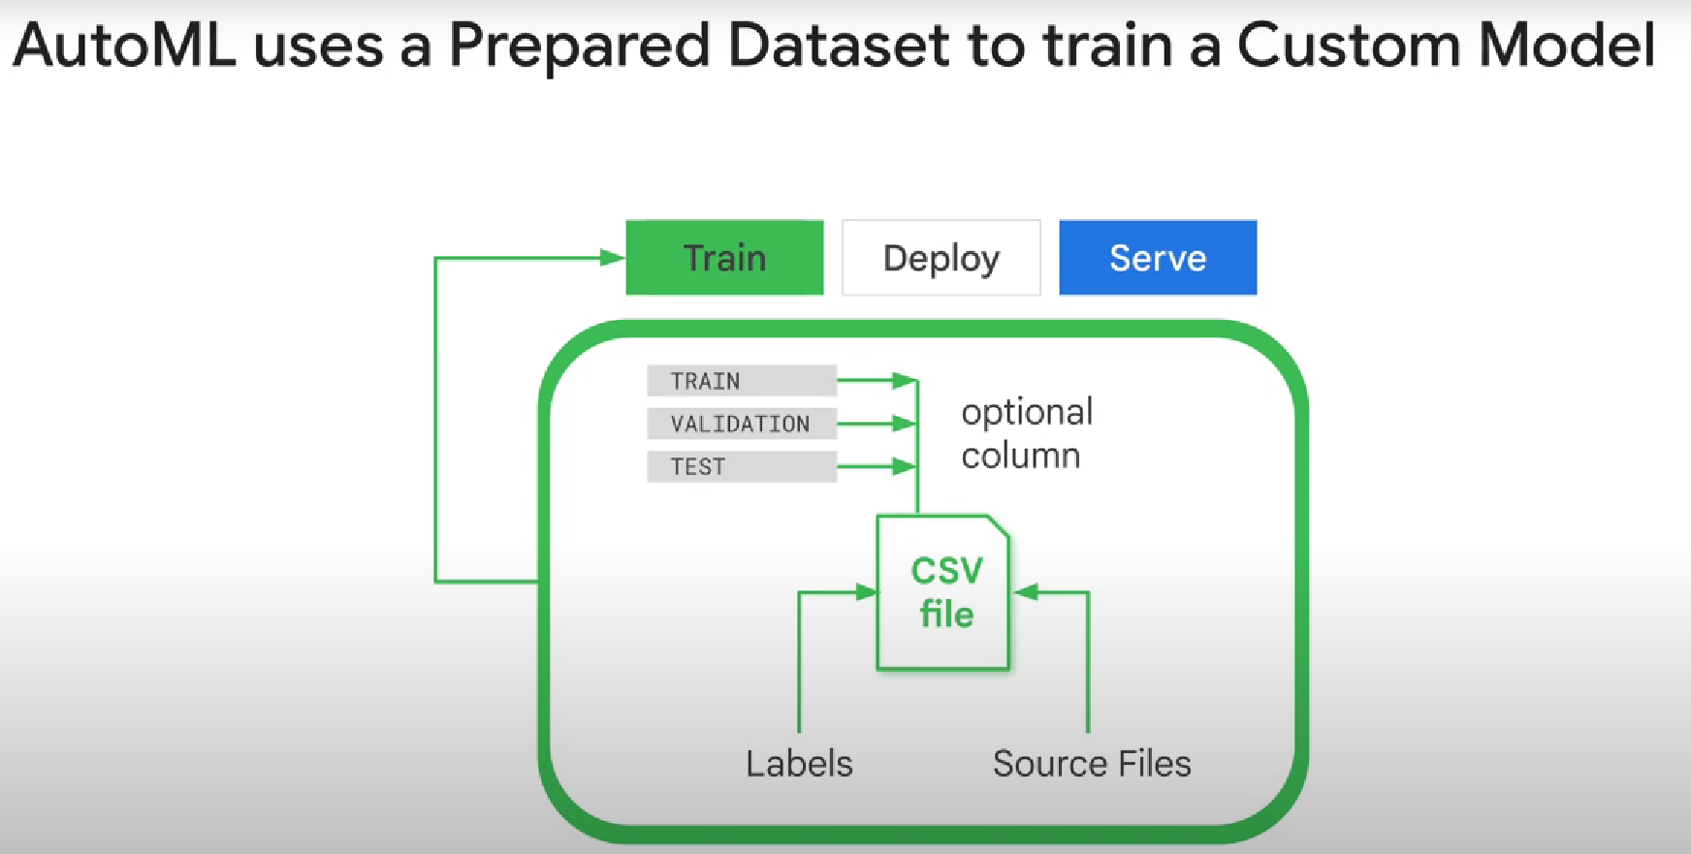

The first column is optional. It indicates wether the row is used for train, validation, or train.

If it’s not added, the rows will automatically be assigned with 80% of the data going to train, and 10% validation and 10% test

The next column in the CSV file identifies source files that are hosted in cloud storage. These are parts beginning with GS://. The source file format depends on the kind of model you are training but can also be compressed ZIP files.

Subsequent columns specify labels.The labels are alphanumeric and can contain underscores but not special characters. The CSV files should not contain duplicate lines and may not contain blank lines or Unicode characters. Currently the CSV file and all the source files must be in a cloud storage bucket in the project where AutoML runs.

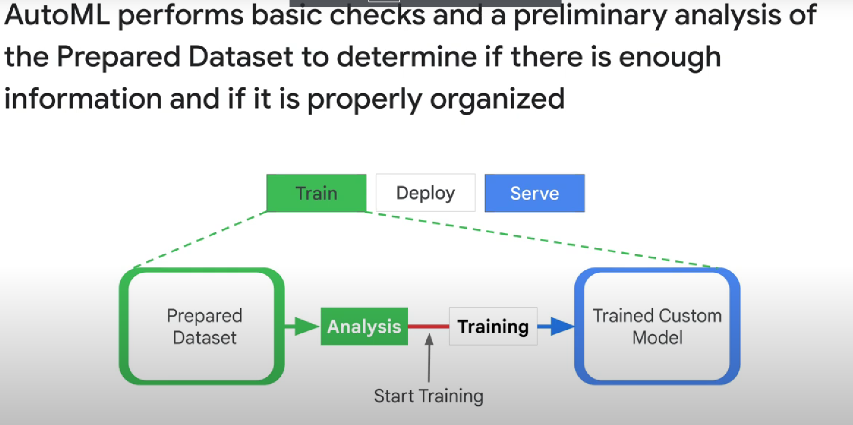

Note:

One full run through all the trained group data is called an epoch.

Models are deleted after a certain time. If you want to use your model for a long time, you’ll need to train it with a new (can be the same) dataset before it gets delete, which will create a «new» model that you can use.

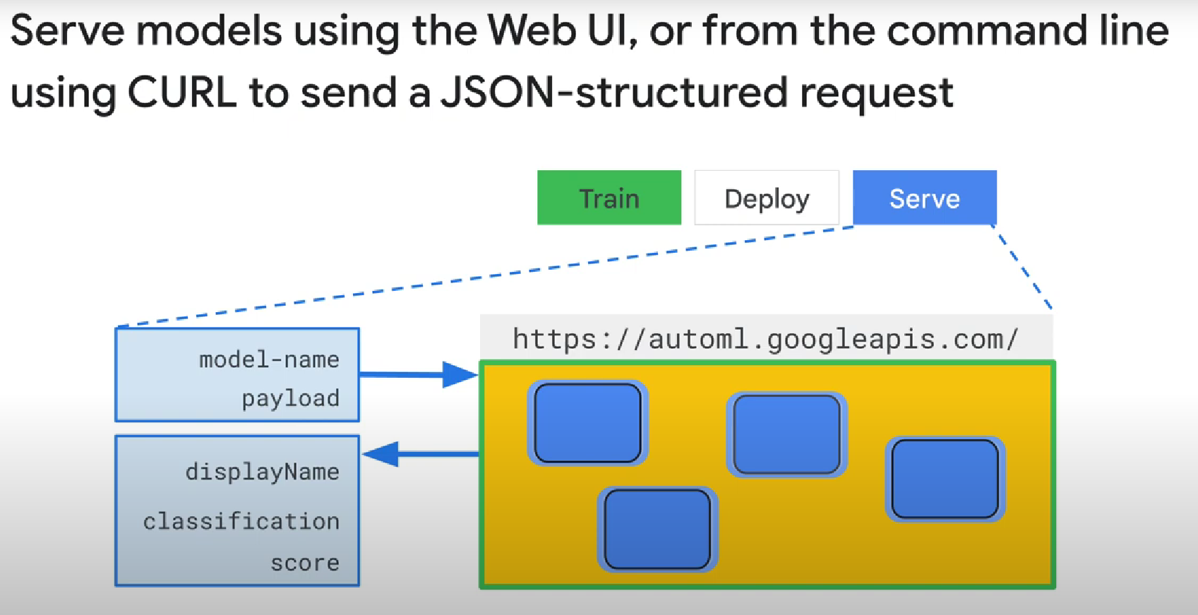

Because it’s so easy to create models in autoML, you can easily create many models, each one responsible for identifying a certain label that you’ll use as a feature in the next model, and link them together:

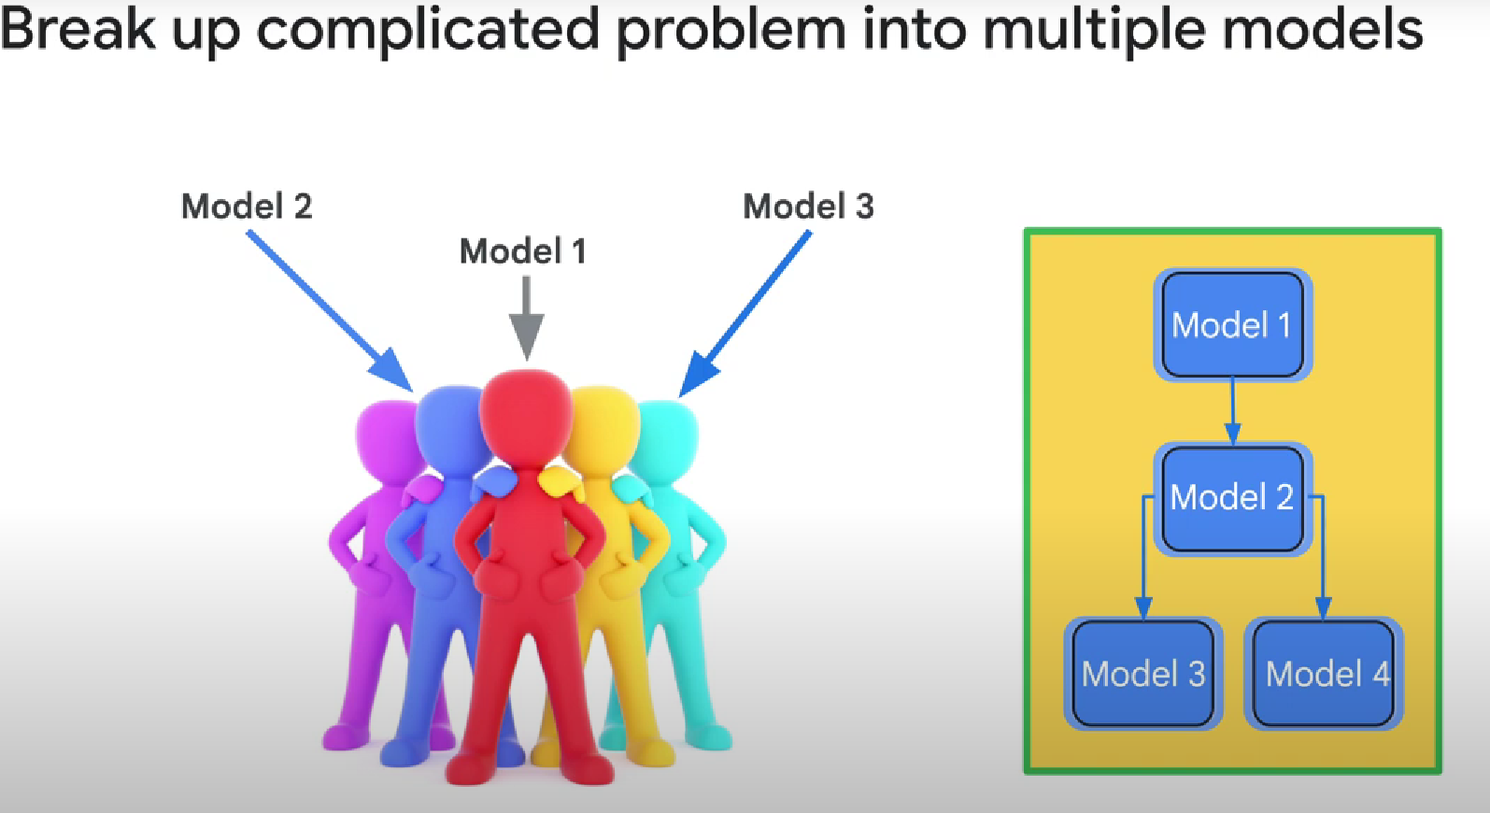

(This could be more efficient than 1 big model)

You can also programmatically combine your custom model with a standard model, such as the Cloud Natural Language API.

Which google cloud ML service to use:

